**St Francis Church of England Primary School**



At St Francis CE Primary School, we aim to inspire our church school family to learn earnestly, care deeply, grow boldly and find joy in the journey nourished by faith, friendship, aspiration and love.

**Policy Title:**

MODERN FOREIGN LANGUAGE POLICY

|  |  |  |  |  |
| --- | --- | --- | --- | --- |
| **Date of Policy:** | Spring Term 2020 |  | **Review Cycle:** | Annually |
| **Policy Review Date:** | Summer Term 2021 | **Updates:** | Updated role of teachers in line with changes to T+L policy, made link changes to new EYFS documentation, split planning and assessment, included teaching model, made links to T+L policy for planning and assessment, included Mode A:Mode B teaching. | |
| **Policy Review Date:** | Feb 2022 | **Updates:** |  | |
| **Policy Review Date:** | September 2025 | **Updates:** | Updated the new vision, staffing and change of HT. Assessment section updated. | |
| **Policy Review Date:** |  | **Updates:** |  | |

Headteacher: C.Foster Chair of Governors: N.Duffy

1. **SUBJECT VISION**

During their time in Key Stage 2 the children of St. Francis will be provided with a rich curriculum that supplies the four cornerstones of using a foreign language: reading, writing, listening and speaking. Learning steps will be in place so that prior learning is constantly accessed and children will continuously accumulate an invaluable life-skill. Threaded throughout their learning will be an engaging element of culture. Our elected foreign language is French and children will be exposed to not only the language of France (and other French-speaking communities) but will also learn of its rich history and culture.

1. **LEGAL FRAMEWORK**

This policy will have regard to the following statutory and non-statutory guidance within the primary national curriculum. Available at: [Primary National Curriculum](https://www.gov.uk/government/uploads/system/uploads/attachment_data/file/425601/PRIMARY_national_curriculum.pdf)

1. **ROLES AND RESPONSIBILITIES**

**4.1 Role of Subject Leader**

The Teaching and Learning Policy, page 3 – section 1.3 states:

*‘Subject Leaders will:*

* *Develop and review curriculum policies and schemes of work in collaboration with colleagues.*
* *Ensure that all relevant required subject leadership paperwork is carried out, for example, subject action plan and leader reports.*
* *Take accountability for the progress of children in their given subject.*
* *Report on the effectiveness of the curriculum to the senior leadership team and the governing body.*
* *Provide professional advice to the governors’ curriculum sub-committee.*
* *Ensure their Scheme of Work details the following: National Curriculum coverage, Objectives, Precise Knowledge, Vocabulary, Links to visits/visitors/experience, Map of prior learning, Links to SMSC, Christian values and mission statement.*
* *Keep up-to-date through reading and attending relevant courses*
* *Sharing subject knowledge and pedagogy amongst colleagues to distribute best practice across the school’*

**4.2 Role of Class Teacher**

The Teaching and Learning Policy, page 3-4 – section 1.4 states:

*‘Teachers will:*

* *Teach using the instructional and pupil culture routine to echo the learning science the teaching and learning is based upon.*
* *Have strong formative assessment within lessons that drives their instruction to ensure children’s learning needs are met.*
* *Hold the mindset of ‘No-opt Out’; ensure 100% compliance and utilise routines to ensure high engagement in learning from all children, irrespective of ability*
* *Utilise mixed ability or flexible groups to meet need.*
* *Be reflective practitioners.*
* *Take on board all training opportunities provided by changing and adapting teaching pedagogy.*
* *Accurately monitor and evaluate their teaching against the national teaching standards and their appraisal targets.*
* *Seek professional dialogue and constructive criticism from senior leaders, teaching colleagues or subject leaders.*
* *Review and evaluate their planning regularly to ensure it meets with subject consistencies laid out in subject policy and the staff handbook.*
* *Set appropriate and challenging targets for pupils based on ability.*
* *Collaborate with colleagues to moderate pupil achievement.*
* *Involve parents and other professionals in the learning process.*
* *Complete all relevant assessment data required through the assessment cycle.*
* *Promote a growth mindset for the children, utilising metacognitive research.*
* *Consider the welfare and safety of children and act within the safeguarding policy as we believe effective learners have to be safe learners.*
* *Provide a challenging and stimulating curriculum, designed to encourage all children to reach the highest standards of achievement*
* *Ensure that their lessons develop children’s deeper thinking and use strategies to support the transference of knowledge to the long-term memory*
* *Be excellent role models, punctual, well prepared and organised.*
* *Have a positive attitude to change and the development of their own expertise.*
* *Ensure that their teaching promotes the love of learning through the use of a range of strategies, including visits, visitors and experiences.*
* *Manage behaviour consistently through the school’s behaviour policy*

1. **EYFS PROVISION**

The teaching of this subject relates to the following areas of the EYFS framework:

ELG 1. Listening, Attention and Understanding: Listen attentively and respond to what they hear with relevant questions, comments and actions when being read to and during whole class discussions and small group interactions. Make comments about what they have heard and ask questions to clarify their understanding. Hold conversation when engaged in back-and-forth exchanges with their teacher and peers.

ELG 2. Speaking ELG: Participate in small group, class and one-to-one discussions, offering their own ideas, using recently introduced vocabulary. Offer explanations for why things might happen, making use of recently introduced vocabulary from stories, non-fiction, rhymes and poems when appropriate. Express their ideas and feelings about their experiences using full sentences, including use of past, present and future tenses and making use of conjunctions, with modelling and support from their teacher.

The EYFS statutory framework can be found at: [EYFS Statutory Framework](https://assets.publishing.service.gov.uk/government/uploads/system/uploads/attachment_data/file/974907/EYFS_framework_-_March_2021.pdf)

The EYFS non-statutory Development Matters guidance can be found at: [Development Matters](https://assets.publishing.service.gov.uk/government/uploads/system/uploads/attachment_data/file/1004234/Development_Matters_Non-statutory_Curriculum_Guidance_Revised_July_2021.pdf)

1. **THE NATIONAL CURRICULUM**

The teaching of the curriculum for the named subject links directly and ensures appropriate coverage of the Primary National Curriculum.

The Primary National Curriculum can be found at: [Primary National Curriculum](https://www.gov.uk/government/uploads/system/uploads/attachment_data/file/425601/PRIMARY_national_curriculum.pdf)

1. **OUR TEACHING MODEL**

Our teaching and learning is based upon research around how learning works. This is the foundation as to how we teach at St. Francis CEP School.

*Tom Sherrington – Rosenshine’s Principles in Action*

A simple model for how memory works is based on the concept of building schemata in our long-term memory, as follows:

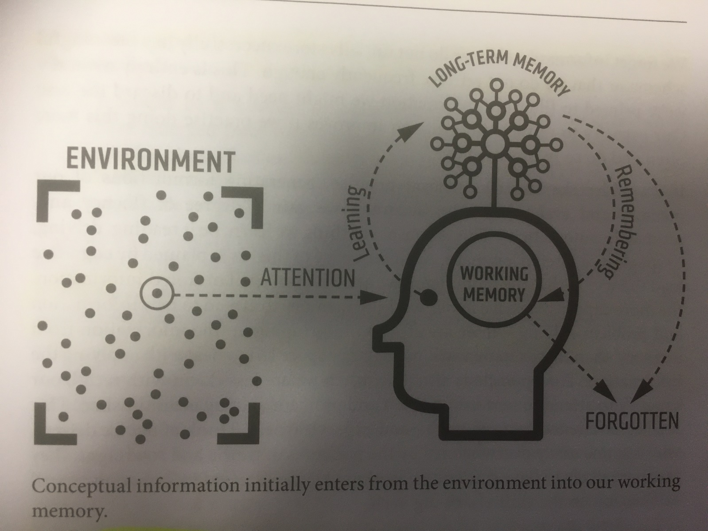

See section 4 of our Teaching and Learning Policy for more information as to how we teach to support this model. Our Teaching and Learning Policy can be found [here](https://www.theschoolbus.net/compliancemanager/public/teaching-and-learning-policy/72469990-a17e-45db-84f4-7cbea92b1738/22619).

Years 3 and 4 follow the comprehensive Catherine Cheater scheme of work while in Upper Key Stage 2, La Jolie Ronde helps to deliver all-encompassing lessons to the children.

1. **PLANNING**

Planning of the subject has been completed to ensure progression in knowledge as the children move through the school. The Long-term plan for this subject area can be found on our curriculum section of our website: [Curriculum Section of Website](https://www.stfranciscep.co.uk/page/curriculum/83640)

The detail of content, including precise knowledge has been set for each year group as outlined in the Long-Term Plan. It is the role of the class teacher to place this into short-term planning to cover in their classes.

The teaching and learning policy demands that teachers plan the outlined content taking consideration of the following:

* Cognitive load
* Learning organisation
* Learning progression
* Learning steps
* Sequential – retrieval practice
* Mode A:Mode B Teaching

The Teaching and Learning Policy, section 5.8 (page 11), defines Mode A:Mode B teaching as:

*During the planning process, the teacher will identify which type of teaching is required.*

*Mode A:*

*Every teacher needs to be able to deliver high-quality instructional teaching. This is Mode A.*

*Explaining, Modelling, Questioning, Checking for Understanding, Guiding Practice.*

*This is identifying when content requires explicit instruction.*

*Mode B:*

*Mode B teaching usually involves content that would benefit from a child-led, curious and inquisitive approach, for example, a science experiment. “I have put some resources on your table, explore and come up with some statements and/or questions to share”*

*Teachers will use instructional routines throughout Mode B teaching.*

*Unlike Mode A teaching, which will be a daily default, Mode B elements can be woven into the curriculum at varying frequencies. Some elements might be daily, some weekly or monthly, some might happen once per unit of learning or just once a year. Mode B elements offer a depth and richness that supplements the staple diet of Mode A. There are no hard and fast rules and whole lessons could easily be devoted entirely to one mode or the other.*

Section five of the teaching and learning policy sets out the processes of planning in our school.

Our Teaching and Learning Policy can be found [here](https://www.theschoolbus.net/compliancemanager/public/teaching-and-learning-policy/72469990-a17e-45db-84f4-7cbea92b1738/22619).

1. **ASSESSMENT**

Written assessments will be completed at the end of Autumn and Spring term. Upon completion of Summer term, a listening and written assessment will be completed.

Section six of the teaching and learning policy sets out the processes of assessment in our school.

Our Teaching and Learning Policy can be found [here](https://www.theschoolbus.net/compliancemanager/public/teaching-and-learning-policy/72469990-a17e-45db-84f4-7cbea92b1738/22619).

1. **SPIRITUAL, MORAL, SOCIAL AND CULTURAL (SMSC) DEVELOPMENT**

Definition of SMSC:

Spiritual

Explore beliefs and experience; respect faiths, feelings and values; enjoy learning about oneself, others and the surrounding world; use imagination and creativity; reflect.

Moral

Recognise right and wrong; respect the law; understand consequences; investigate moral and ethical issues; offer reasoned views.

Social

Use a range of social skills; participate in the local community; appreciate diverse viewpoints; participate, volunteer and cooperate; resolve conflict; engage with the 'British values' of democracy, the rule of law, liberty, respect and tolerance.

Cultural

Appreciate cultural influences; appreciate the role of Britain's parliamentary system; participate in culture opportunities; understand, accept, respect and celebrate diversity.

Opportunities for SMSC throughout the curriculum offer is extremely important. Please see curriculum map to view the intentional and purposeful planning of SMSC learning.

1. **MONITORING**

French will be monitored once a term by the Subject by looking at the classroom environment, the work produced in lessons and through pupil voice.

1. **SPECIAL EDUCATION NEEDS AND/OR DISABILITY**

See our Special Educational Needs and/or Disability policy [here](https://www.theschoolbus.net/compliancemanager/public/special-educational-needs-and-disabilities-policy/1a35776c-9245-418f-a5f2-4624bd6bd839/41359).

1. **HEALTH AND SAFETY CONSIDERATIONS**
2. There may be a time in the delivering of the curriculum where food tasting is appropriate to introduce. At this point, class teachers should refer to their classes allergies and dietary information before organising and/or delivering a lesson of this nature.

See our Health and Safety policy [here](https://www.theschoolbus.net/compliancemanager/public/health-and-safety-policy/580fd565-bd1e-46dc-95e0-56426a003a37/16602).

1. **RESOURCES, INCLUDING SUITABLE TEXTS**

See curriculum map with the above included. ([Curriculum Section of Website](https://www.stfranciscep.co.uk/page/curriculum/83640))

1. **COMMUNITY LINKS – LOCAL AND GLOBAL**

See curriculum map with the above included. ([Curriculum Section of Website](https://www.stfranciscep.co.uk/page/curriculum/83640))

1. **VISITS, VISITORS AND EXPERIENCES**

See curriculum map with the above included. ([Curriculum Section of Website](https://www.stfranciscep.co.uk/page/curriculum/83640))