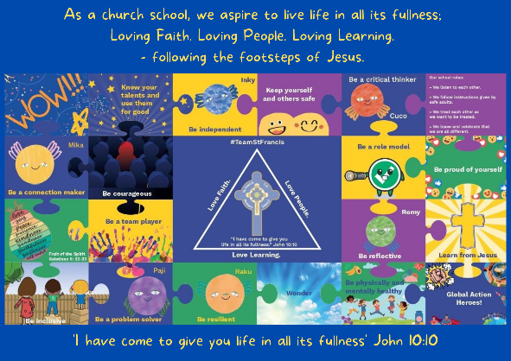
Personal, Social, Emotional, Health and Economic Education

St Francis PSHE Curriculum

Year 6 End points:
1. Being able to think things through and make good choices.
2. Having self-confidence and self-awareness.
3. Taking care of your physical health.
4. Keeping yourself and others safe.
5. Being community minded.
6. Having aspirational thoughts and the ability to plan for the future.
7. Being able to make and maintain healthy friendships.
8. Putting EDJ into practice.

In Year 5, we work on:
 | Big Question | PSHE Strand | End Point
Aut 1 | How can friends communicate safely? | Relationships | 7. Being able to make and maintain healthy friendships.
Aut 2 | What makes up a person’s identity? | Mental Wellbeing | 2. Having self-confidence and self-awareness.
Spr 1 | How can we help in an accident or emergency? | Safety | 4. Keeping yourself and others safe.
Spr 2 | How can drugs common to everyday life affect health? | Physical Health | 3. Taking care of your physical health.
Sum 1 | What are our rights and responsibilities? | Relationships | 8. Putting EDJ into practice.
Sum 2 | What decisions can people make with money? | Wider World | 6. Having aspirational thoughts and the ability to plan for the future.
