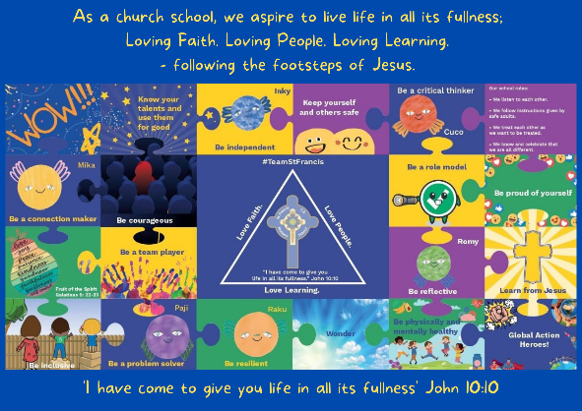
Personal, Social, Emotional, Health and Economic Education

St Francis PSHE Curriculum

Year 6 End points:
1. Being able to think things through and make good choices.
2. Having self-confidence and self-awareness.
3. Taking care of your physical health.
4. Keeping yourself and others safe.
5. Being community minded.
6. Having aspirational thoughts and the ability to plan for the future.
7. Being able to make and maintain healthy friendships.
8. Putting EDJ into practice.

In Year 3, we work on:
 | Big Question | PSHE Strand | End Point
Aut 1 | How can we be good friends? | Relationships | 7. Being able to make and maintain healthy friendships.
Aut 2 | Why should we make healthy choices? | Physical Health | 3. Taking care of your physical health.
Spr 1 | What makes a community? | Wider World | 5. Being community minded.
Spr 2 | How can we manage our feelings? | Mental Wellbeing | 1. Being able to think things through and make good choices.
Sum 1 | What are families like? | Relationships | 8. Putting EDJ into practice.
Sum 2 | How can we stay safe? | Safety | 4. Keeping yourself and others safe.
