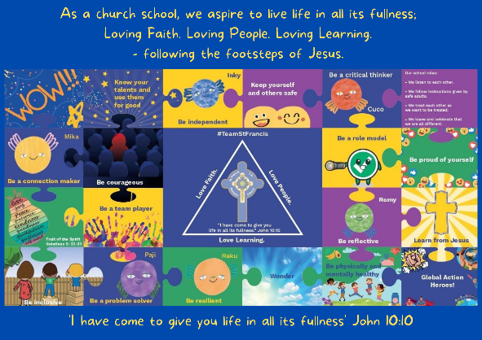
Personal, Social, Emotional, Health and Economic Education

St Francis PSHE Curriculum

Year 6 End points:
1. Being able to think things through and make good choices.
2. Having self-confidence and self-awareness.
3. Taking care of your physical health.
4. Keeping yourself and others safe.
5. Being community minded.
6. Having aspirational thoughts and the ability to plan for the future.
7. Being able to make and maintain healthy friendships.
8. Putting EDJ into practice.

In Year 6, we work on:
 | Big Question | PSHE Strand | End Point
Aut 1 | How can we keep healthy as we grow? | Physical Health | 3. Taking care of your physical health.
Aut 2 | How can the media influence people? | Safety | 2. Having self-confidence and self-awareness.
Spr 1 | How can we make good decisions? | Mental Wellbeing | 1. Being able to think things through and make good choices.
Spr 2 | What do I want for my future? | Wider World | 6. Having aspirational thoughts and the ability to plan for the future.
Sum 1 | How do friendships change as we grow? | Relationships | 7. Being able to make and maintain healthy friendships.
Sum 2 | What will change as we become more independent? | Relationships | 8. Putting EDJ into practice.
