St Francis Church of England Primary School

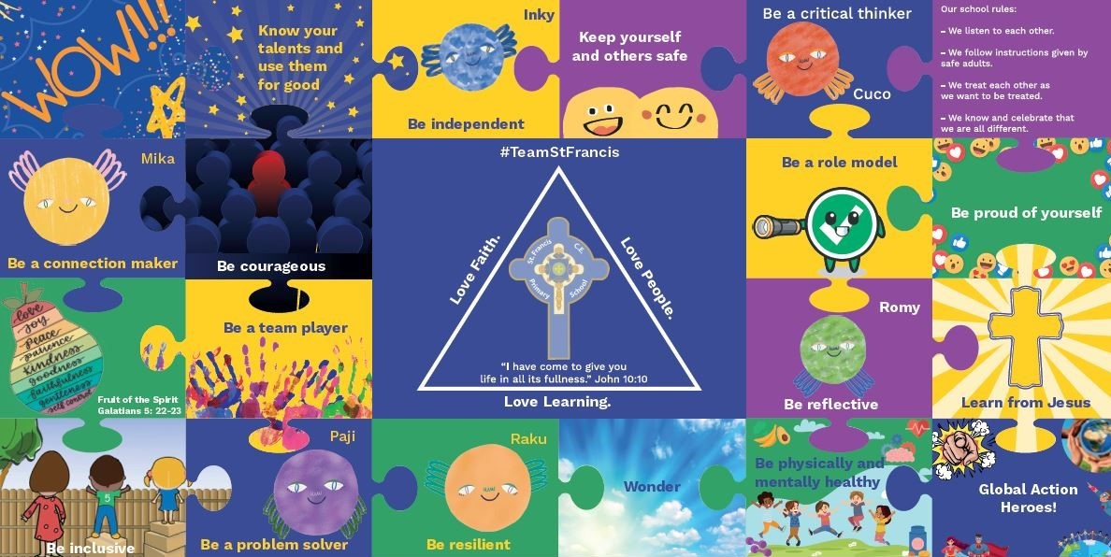

Our vision, mission statement and values are at the core of everything we do. They underpin our teaching and learning, interactions and environment.

Policy Title:

Times Tables Policy

Date of Policy: | Autumn Term 2022 |  | Review Cycle: | Annually
Policy Review Date: | Summer Term 2023 | Updates: | Updated role of teachers in line with changes to T+L policy, made link changes to new EYFS documentation, split planning and assessment, included teaching model, made links to T+L policy for planning and assessment, included Mode A:Mode B teaching.
Policy Review Date: |  | Updates:
Policy Review Date: |  | Updates:
Policy Review Date: |  | Updates:

Headteacher: J.Kewley Chair of Governors: N.Duffy
- MODEL OF CURRICULUM

- SUBJECT VISION

At St. Francis, we want our children to be fluent in all times tables up to 12 x 12 by the time they take the Multiplication Tables Check in summer term of Year 4. Not only will this prepare the children for the assessment, it will also underpin several units the children will cover working form the White Rose curriculum from EYFS to Year 6.

- LEGAL FRAMEWORK

This policy will have regard to the following statutory and non-statutory guidance within the primary national curriculum. Available at: Primary National Curriculum

- ROLES AND RESPONSIBILITIES
4.1 Role of Subject Leader

The Teaching and Learning Policy, page 3 – section 1.3 states:
‘Subject Leaders will:
- Develop and review curriculum policies and schemes of work in collaboration with colleagues.
- Ensure that all relevant required subject leadership paperwork is carried out, for example, subject action plan and leader reports.
- Take accountability for the progress of children in their given subject.
- Report on the effectiveness of the curriculum to the senior leadership team and the governing body.
- Provide professional advice to the governors’ curriculum sub-committee.
- Ensure their Scheme of Work details the following: National Curriculum coverage, Objectives, Precise Knowledge, Vocabulary, Links to visits/visitors/experience, Map of prior learning, Links to SMSC, Christian values and mission statement.
- Keep up-to-date through reading and attending relevant courses
- Sharing subject knowledge and pedagogy amongst colleagues to distribute best practice across the school’

4.2 Role of Class Teacher

The Teaching and Learning Policy, page 3-4 – section 1.4 states:
‘Teachers will:
- Teach using the instructional and pupil culture routine to echo the learning science the teaching and learning is based upon.
- Have strong formative assessment within lessons that drives their instruction to ensure children’s learning needs are met.
- Hold the mindset of ‘No-opt Out’; ensure 100% compliance and utilise routines to ensure high engagement in learning from all children, irrespective of ability
- Utilise mixed ability or flexible groups to meet need.
- Be reflective practitioners.
- Take on board all training opportunities provided by changing and adapting teaching pedagogy.
- Accurately monitor and evaluate their teaching against the national teaching standards and their appraisal targets.
- Seek professional dialogue and constructive criticism from senior leaders, teaching colleagues or subject leaders.
- Review and evaluate their planning regularly to ensure it meets with subject consistencies laid out in subject policy and the staff handbook.
- Set appropriate and challenging targets for pupils based on ability.
- Collaborate with colleagues to moderate pupil achievement.
- Involve parents and other professionals in the learning process.
- Complete all relevant assessment data required through the assessment cycle.
- Promote a growth mindset for the children, utilising metacognitive research.
- Consider the welfare and safety of children and act within the safeguarding policy as we believe effective learners have to be safe learners.
- Provide a challenging and stimulating curriculum, designed to encourage all children to reach the highest standards of achievement
- Ensure that their lessons develop children’s deeper thinking and use strategies to support the transference of knowledge to the long-term memory
- Be excellent role models, punctual, well prepared and organised.
- Have a positive attitude to change and the development of their own expertise.
- Ensure that their teaching promotes the love of learning through the use of a range of strategies, including visits, visitors and experiences.
- Manage behaviour consistently through the school’s behaviour policy

- THE NATIONAL CURRICULUM
The teaching of the curriculum for the named subject links directly and ensures appropriate coverage of the Primary National Curriculum.

The Primary National Curriculum can be found at: Primary National Curriculum

- OUR TEACHING MODEL
Our teaching and learning is based upon research around how learning works. This is the foundation as to how we teach at St. Francis CEP School.

Tom Sherrington – Rosenshine’s Principles in Action
A simple model for how memory works is based on the concept of building schemata in our long-term memory, as follows:
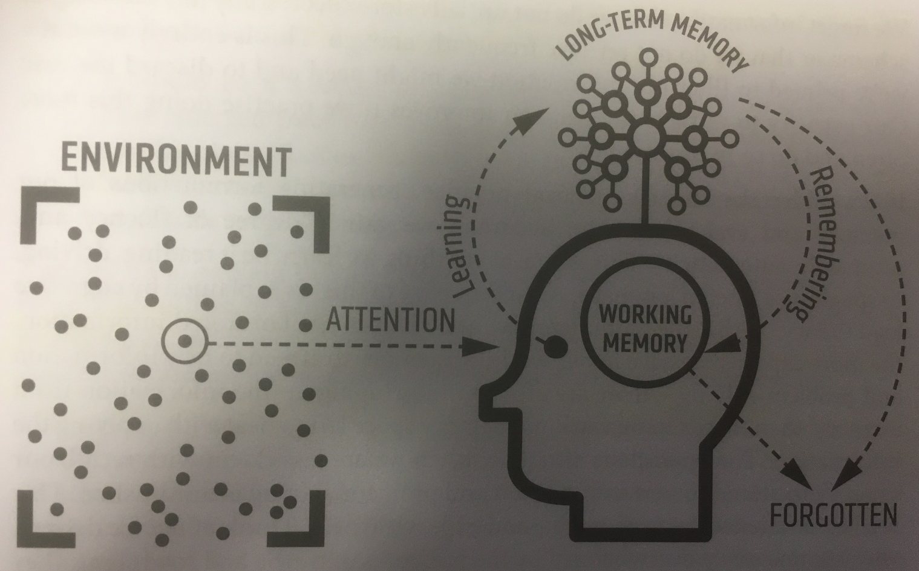

See section 4 of our Teaching and Learning Policy for more information as to how we teach to support this model. Our Teaching and Learning Policy can be found here.

The ‘Times Table Time’ at St. Francis (aimed at Years 2, 3 and 4) will be a focussed, 15-minute session after lunch where children will work on a times table of their choice, for that week. The levels the children will be working at will be bronze, silver and gold. To achieve bronze level, the children will need to be able to recite their chosen times table without delay, gaps or mistakes. To achieve silver, the children will be quizzed in a random order by the class teacher or supporting adult in class; to be successful, responses must be swift and without error. To achieve gold level, the children must be able to introduce inverse operations to their thinking. Again, tested by the class teacher or supporting adult, they should confidently be able to answer a mixture of multiplication and division questions on their chosen times table.

Year Group | Times Table Focus
2 | 2, 5 and 10
3 | 11, 3, 4 and 8
4 | 6, 7, 9 and 12

- PLANNING
Planning of the subject has been completed to ensure progression in knowledge as the children move through the school. The Long-term plan for this subject area can be found on our curriculum section of our website: Curriculum Section of Website

The detail of content, including precise knowledge has been set for each year group as outlined in the Long-Term Plan. It is the role of the class teacher to place this into short-term planning to cover in their classes.
The teaching and learning policy demands that teachers plan the outlined content taking consideration of the following:
- Cognitive load
- Learning organisation
- Learning progression
- Learning steps
- Sequential – retrieval practice
- Mode A:Mode B Teaching
The Teaching and Learning Policy, section 5.8 (page 11), defines Mode A: Mode B teaching as:

During the planning process, the teacher will identify which type of teaching is required.

Mode A:
Every teacher needs to be able to deliver high-quality instructional teaching. This is Mode A.
Explaining, Modelling, Questioning, Checking for Understanding, Guiding Practice.
This is identifying when content requires explicit instruction.

Mode B:
Mode B teaching usually involves content that would benefit from a child-led, curious and inquisitive approach, for example, a science experiment. “I have put some resources on your table, explore and come up with some statements and/or questions to share”

Teachers will use instructional routines throughout Mode B teaching.

Unlike Mode A teaching, which will be a daily default, Mode B elements can be woven into the curriculum at varying frequencies. Some elements might be daily, some weekly or monthly, some might happen once per unit of learning or just once a year. Mode B elements offer a depth and richness that supplements the staple diet of Mode A. There are no hard and fast rules and whole lessons could easily be devoted entirely to one mode or the other.

Section five of the teaching and learning policy sets out the processes of planning in our school.

Our Teaching and Learning Policy can be found here.

- ASSESSMENT

Our Teaching and Learning Policy can be found here.

- SPIRITUAL, MORAL, SOCIAL AND CULTURAL (SMSC) DEVELOPMENT
Definition of SMSC:
Spiritual
Explore beliefs and experience; respect faiths, feelings and values; enjoy learning about oneself, others and the surrounding world; use imagination and creativity; reflect.

Moral
Recognise right and wrong; respect the law; understand consequences; investigate moral and ethical issues; offer reasoned views.

Social
Use a range of social skills; participate in the local community; appreciate diverse viewpoints; participate, volunteer and cooperate; resolve conflict; engage with the 'British values' of democracy, the rule of law, liberty, respect and tolerance.

Cultural
Appreciate cultural influences; appreciate the role of Britain's parliamentary system; participate in culture opportunities; understand, accept, respect and celebrate diversity.

Opportunities for SMSC throughout the curriculum offer is extremely important. Please see curriculum map to view the intentional and purposeful planning of SMSC learning.

- MONITORING
Academic Year:  20__/20__ | Autumn Term |  | Spring Term |  | Summer Term
 | Autumn 1 | Autumn 2 | Spring 1 | Spring 2 | Summer 1 | Summer 2
Leadership / Moving your Subject On |  |  |  |  |  | X
Assessment Analysis | X | X | X | X | X | X
Monitoring  (Book looks / MTP scrutiny) | n/a | n/a | n/a | n/a | n/a | n/a
Updating Subject Leadership File
Resources Audit / Ordering Resources |  |  |  |  |  | X
Completion of Subject Reports / Updating Action Plan |  |  |  |  | X

- SPECIAL EDUCATION NEEDS AND/OR DISABILITY
See our Special Educational Needs and/or Disability policy here.

- HEALTH AND SAFETY CONSIDERATIONS
Children will be working with concrete resources, some with sharp edges, some of a certain size. Before administering the resources, talk takes place about not only caring for the equipment but using it in a safe and secure way.

See our Health and Safety policy here.

- RESOURCES, INCLUDING SUITABLE TEXTS
See curriculum map with the above included. (Curriculum Section of Website)

- COMMUNITY LINKS – LOCAL AND GLOBAL
See curriculum map with the above included. (Curriculum Section of Website)

- VISITS, VISITORS AND EXPERIENCES
See curriculum map with the above included. (Curriculum Section of Website)

