What should I already know?
- The past has already happened.
- Some things have changed from the past to the present day.
- I know that there are similarities and differences in relation to places, objects, materials and living things.
What will I find out by the end of the unit?
Victorian school | School within living memory
- Children had to be in school until the age of 12.  - After that children could leave school to go to work.  What did they learn?  - Reading, writing and arithmetic were taught for most of the day.  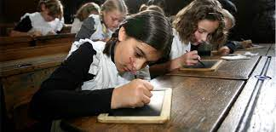  Writing on slate  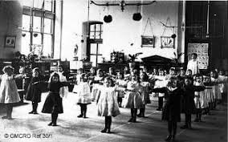  Drill exercises  The school day  - School morning was 9am – 12pm.  - Children went home for lunch.  - Afternoons ran from 2pm-5pm.  Punishments  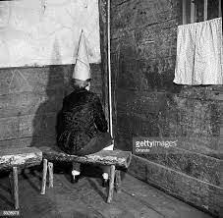  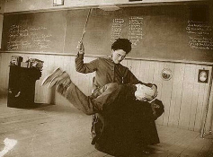 | All children have to go to school until they are 16.  What did they learn?  - Children were taught reading, writing and maths each day with other lessons such as geography, history.  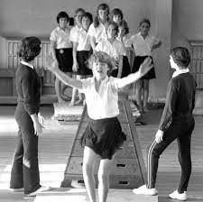  PE instead of drills  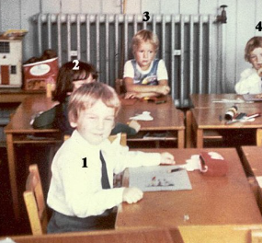  Sitting at desks using pencil and paper  Teachers would either stand at the front or sit at a desk. Children would queue up at the desk to have work marked.  The school day  - School runs from 9am – 3:30pm and children stay in school for lunch.  Punishments  - 1984 a law banned the use of punishment by hitting at home or in school.  - Teachers were still strict.
Vocabulary
arithmetic | maths – addition, subtraction, multiplication, division
abacus | a piece of equipment for counting
drill | exercise done by the side of the desk
slate | type of flat stone for writing on
cane | long thin piece of wood
dunce’s hat | hat worn by a child who cannot keep up in class
banned | stopped from doing something
beat | to hit someone or something

How can we find out about the past?
- We can talk to someone who was around at the time – ask questions.
- We can look at photographs or paintings.
- We can read books about that time.
- We can read the diaries of people around at the time.
- We can watch historical films about the period in history.

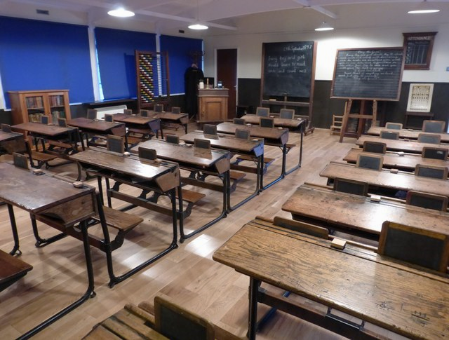
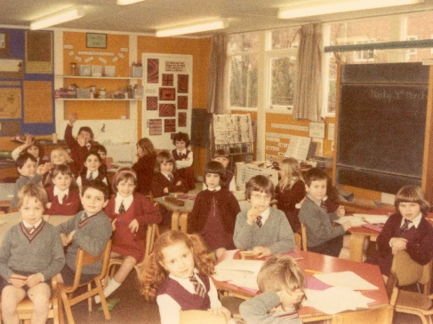
abacus blackboard displays blackboard blackboar

plain walls
desks in rows slates desks in groups paper

