What should I already know?
- The names of different toys.
- Toys I like to play with.
- The past has already happened.
- Some things have changed from the past to the present day.
What will I find out by the end of the unit?
Past |  | Present
- Victorian rich girls played with dolls and tea sets, and rich boys played with toy soldiers and marbles.  - Poor families did not have enough money for toys, so made their own.  - Toys in the past had cogs, levers and pulleys to make them move.  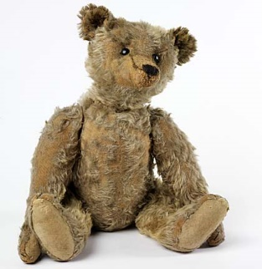  - Toys were made from wood or metal.  - Old teddy bears have hard bodies and sometimes rough fur.  - Their joints move. | - Modern toys are mostly made from plastic.  - Modern toys need batteries or electricity to make them work or move.  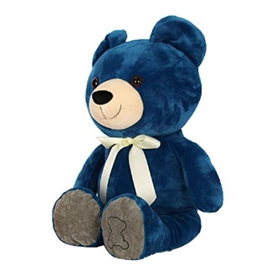  - Children now play video games.  - Modern day teddy bears can be all sorts of colours.  - They are soft and cuddly.
Vocabulary
Victorian | during the time of Queen Victoria
past | already happened
present | is happening now
modern | now or recently
mechanical | toy with moving parts  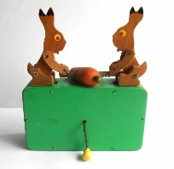
electrical | works by electricity
video game | a game played on a screen
living memory | history that can be remembered and told to you
clockwork | 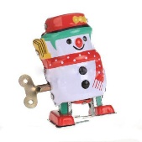  wind-up toy
battery operated | 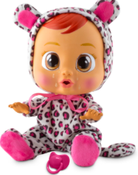  needs a battery to make it work

Historical skills and enquiry
- VAK timeline of British History.
- Investigate different toys and say if they are old or new.
- Investigate toys and say how they are the same or different.
- Play games from the past. How are they similar or different?
- Investigate teddy bears. How can I tell if they are old or new?

