What should I already know?
- I go to St. Francis School.
- Our school is in Blackburn.
- I can name features in my immediate environment.

Vocabulary
aerial | View from above on a map.
local | Within an area of the immediate environment.
location | Where something is. A particular place.
area | Part of a town.
symbol | A picture that represents/stands for a word/s.
key | A list which explains what symbols represent/stand for.
bridge | A structure over a waterway or road.
canal | A man-made waterway carrying small boats and barges.
human features | Features of the land that have been put there by humans.
physical features | Natural features of the land.
town | A large group of houses, shops and buildings where people live and work. Towns are larger than villages but smaller than cities. Blackburn is a town.
England | The country we live in. Blackburn is in England.
directions | Where a person or thing moves or is located.
plan | map of a room from above
What will I find out?
- St. Francis is on Cherry Tree Lane.
- St Francis is in Cherry Tree.
- Cherry Tree is an area of Blackburn.
- Blackburn is a town in England.
- The school field includes grass and trees.
- There is a field with trees outside of the school grounds.
- Cherry Tree Lane has a library, nursery and school.
- Beside the school there is a canal with a bridge over it. The bridge means we can get to the other side of the canal.
- There is a library on the lane and a nursery. These are helpful places to have near a school.

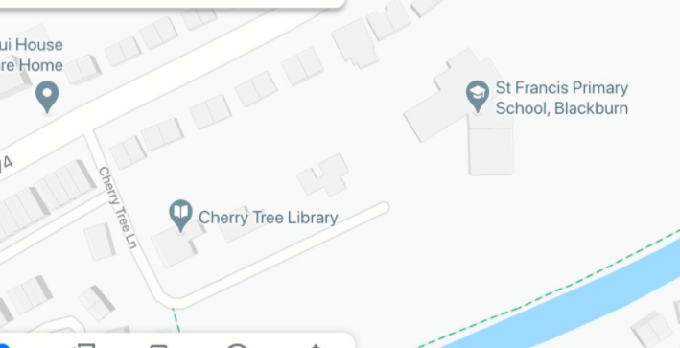

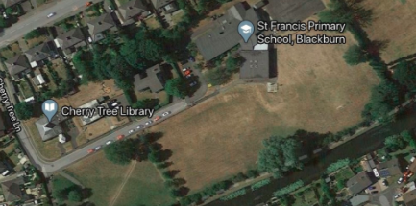
Lane An aerial view of our school

Geography skills and fieldwork
- Use an aerial map of the immediate area to find our school and the features in the immediate environment.
- Draw a map of the classroom with a key.
- Name features of the local area on their journey to school.
- Describe the human and physical features of the immediate area.
- Name a feature of the locality they like and dislike.
School field

Trees

Canal
Field

