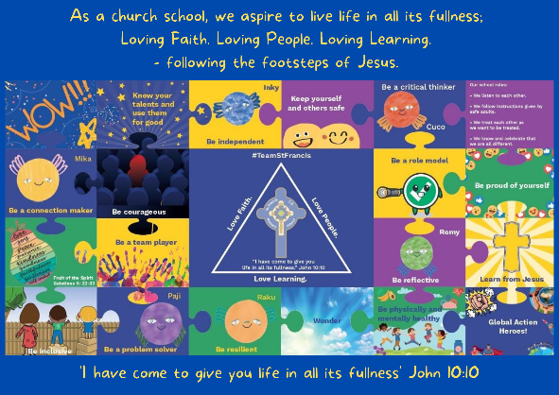
Personal, Social, Emotional, Health and Economic Education

St Francis PSHE Curriculum

Year 6 End points:
1. Being able to think things through and make good choices.
2. Having self-confidence and self-awareness.
3. Taking care of your physical health.
4. Keeping yourself and others safe.
5. Being community minded.
6. Having aspirational thoughts and the ability to plan for the future.
7. Being able to make and maintain healthy friendships.
8. Putting EDJ into practice.

In Year 1, we work on:
 | Big Question | PSHE Strand | End Point
Aut 1 | What is the same and different about us? | Relationships | 8. Putting EDJ into practice.
Aut 2 | Who is special to us? | Relationships | 7. Being able to make and maintain healthy friendships.
Spr 1 | How can we look after each other and the world? | Wider World | 5. Being community minded.
Spr 2 | How do we recognise our feelings? | Mental Wellbeing | 1. Being able to think things through and make good choices.
Sum 1 | What does healthy mean? | Physical Health | 3. Taking care of your physical health.
Sum 2 | Who helps to keep us safe? | Safety | 4. Keeping yourself and others safe.
