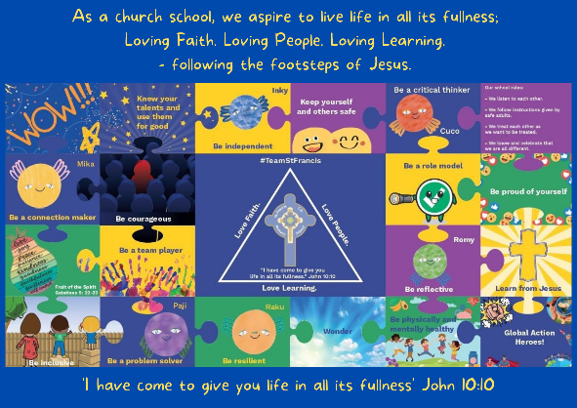
Personal, Social, Emotional, Health and Economic Education

St Francis PSHE Curriculum

Year 6 End points:

1. Being able to think things through and make good choices.
2. Having self-confidence and self-awareness.
3. Taking care of your physical health.
4. Keeping yourself and others safe.
5. Being community minded.
6. Having aspirational thoughts and the ability to plan for the future.
7. Being able to make and maintain healthy friendships.
8. Putting EDJ into practice.

In EYFS, we work on:
 | Big Question | PSHE Strand | End Point
Aut 1 | What is great about you? | Mental Wellbeing | 2. Having self-confidence and self-awareness.
Aut 2 | What does being kind look like? | Relationships | 7. Being able to make and maintain healthy friendships.
Spr 1 | How are we the same and different? | Relationships | 8. Putting EDJ into practice.
Spr 2 | What might you do in the future? | Wider World | 6. Having aspirational thoughts and the ability to plan for the future.
Sum 1 | How can we show feelings? | Mental Wellbeing | 1. Being able to think things through and make good choices.
Sum 2 | How can we keep healthy? | Physical Health | 3. Taking care of your physical health.
