St Francis Church of England Primary School

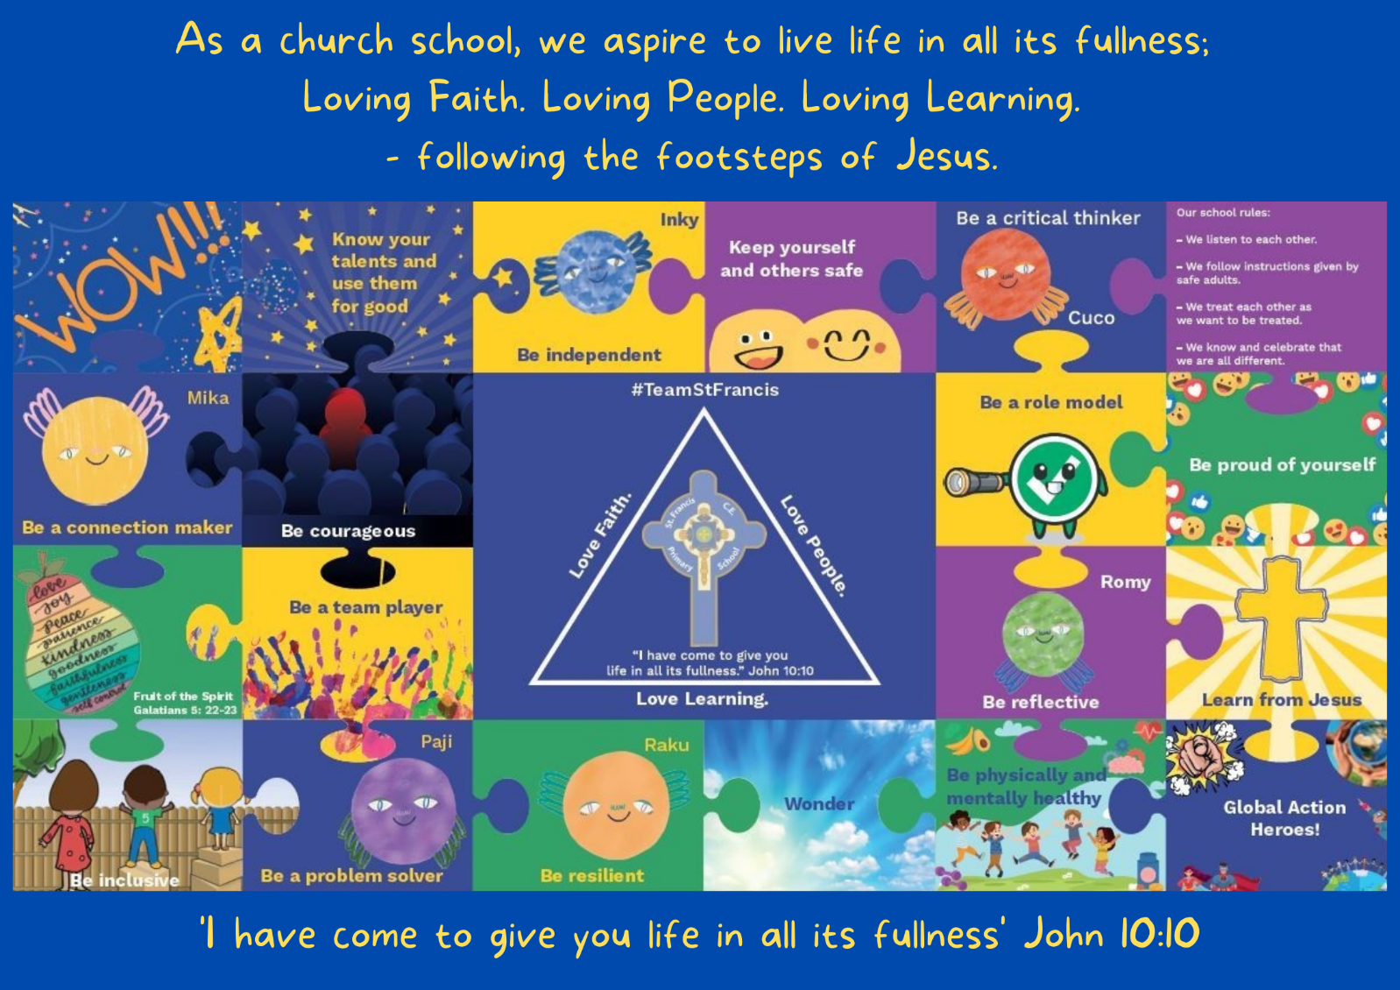
Our vision is at the core of everything we do. It underpins our teaching and learning, interactions and environment.

Policy Title:

Design and Technology Policy

Date of Policy: | Spring Term 2020 |  | Review Cycle: | Annually
Policy Review Date: | Summer Term 2021 | Updates: | Updated role of teachers in line with changes to T+L policy, made link changes to new EYFS documentation, split planning and assessment, included teaching model, made links to T+L policy for planning and assessment, included Mode A:Mode B teaching.
Policy Review Date: | Spring term 2022 | Updates: | The teaching of DT added to policy in line with the T+L policy.
Policy Review Date: | Autumn 2022 | Updates: | Updates school vision jigsaw.
Policy Review Date: |  | Updates:

Headteacher: J.Kewley Chair of Governors: N.Duffy

- MODEL OF CURRICULUM

- SUBJECT VISION

Children use their creativity and imagination to design purposeful products that solve real and relevant problems. They utilise art and computing skills to support the design process. They select appropriate materials and tools, based on their growing technical knowledge, in order to construct their product to the highest standard. During the design and making stage, children take the opportunity to reflect and evaluate their product, making changes as required to ensure their finished product meets the brief.

- LEGAL FRAMEWORK

This policy will have regard to the following statutory and non-statutory guidance within the primary national curriculum. Available at: Primary National Curriculum

- ROLES AND RESPONSIBILITIES
4.1 Role of Subject Leader

The Teaching and Learning Policy, page 3 – section 1.3 states:
‘Subject Leaders will:
- Develop and review curriculum policies and schemes of work in collaboration with colleagues.
- Ensure that all relevant required subject leadership paperwork is carried out, for example, subject action plan and leader reports.
- Take accountability for the progress of children in their given subject.
- Report on the effectiveness of the curriculum to the senior leadership team and the governing body.
- Provide professional advice to the governors’ curriculum sub-committee.
- Ensure their Scheme of Work details the following: National Curriculum coverage, Objectives, Precise Knowledge, Vocabulary, Links to visits/visitors/experience, Map of prior learning, Links to SMSC, Christian values and mission statement.
- Keep up-to-date through reading and attending relevant courses
- Sharing subject knowledge and pedagogy amongst colleagues to distribute best practice across the school’

4.2 Role of Class Teacher

The Teaching and Learning Policy, page 3-4 – section 1.4 states:
‘Teachers will:
- Teach using the instructional and pupil culture routine to echo the learning science the teaching and learning is based upon.
- Have strong formative assessment within lessons that drives their instruction to ensure children’s learning needs are met.
- Hold the mindset of ‘No-opt Out’; ensure 100% compliance and utilise routines to ensure high engagement in learning from all children, irrespective of ability
- Utilise mixed ability or flexible groups to meet need.
- Be reflective practitioners.
- Take on board all training opportunities provided by changing and adapting teaching pedagogy.
- Accurately monitor and evaluate their teaching against the national teaching standards and their appraisal targets.
- Seek professional dialogue and constructive criticism from senior leaders, teaching colleagues or subject leaders.
- Review and evaluate their planning regularly to ensure it meets with subject consistencies laid out in subject policy and the staff handbook.
- Set appropriate and challenging targets for pupils based on ability.
- Collaborate with colleagues to moderate pupil achievement.
- Involve parents and other professionals in the learning process.
- Complete all relevant assessment data required through the assessment cycle.
- Promote a growth mindset for the children, utilising metacognitive research.
- Consider the welfare and safety of children and act within the safeguarding policy as we believe effective learners have to be safe learners.
- Provide a challenging and stimulating curriculum, designed to encourage all children to reach the highest standards of achievement
- Ensure that their lessons develop children’s deeper thinking and use strategies to support the transference of knowledge to the long-term memory
- Be excellent role models, punctual, well prepared and organised.
- Have a positive attitude to change and the development of their own expertise.
- Ensure that their teaching promotes the love of learning through the use of a range of strategies, including visits, visitors and experiences.
- Manage behaviour consistently through the school’s behaviour policy

- EYFS PROVISION
The teaching of this subject relates to the following areas of the EYFS framework:

Personal, Social and Emotional Development

ELG 3. Self-Regulation ELG: Show an understanding of their own feelings and those of others, and begin to regulate their behaviour accordingly. Set and work towards simple goals, being able to wait for what they want and control their immediate impulses when appropriate. Give focused attention to what the teacher says, responding appropriately even when engaged in activity, and show an ability to follow instructions involving several ideas or actions.
ELG 4. Managing Self ELG: Be confident to try new activities and show independence, resilience and perseverance in the face of challenge. Explain the reasons for rules, know right from wrong and try to behave accordingly. Manage their own basic hygiene and personal needs, including dressing, going to the toilet and understanding the importance of healthy food choices.

Communication and Language

ELG 1. Listening, Attention and Understanding: Listen attentively and respond to what they hear with relevant questions, comments and actions when being read to and during whole class discussions and small group interactions. Make comments about what they have heard and ask questions to clarify their understanding. Hold conversation when engaged in back-and-forth exchanges with their teacher and peers.

ELG 2. Speaking ELG: Participate in small group, class and one-to-one discussions, offering their own ideas, using recently introduced vocabulary. Offer explanations for why things might happen, making use of recently introduced vocabulary from stories, non-fiction, rhymes and poems when appropriate. Express their ideas and feelings about their experiences using full sentences, including use of past, present and future tenses and making use of conjunctions, with modelling and support from their teacher.

Physical development

ELG 7. Fine Motor Skills: Hold a pencil effectively in preparation for fluent writing – using the tripod grip in almost all cases. Use a range of small tools, including scissors, paint brushes and cutlery. Begin to show accuracy and care when drawing.

Understanding the World

ELG 13. Past and Present: Talk about the lives of the people around them and their roles in society. Know some similarities and differences between things in the past and now, drawing on their experiences and what has been read in class. Understand the past through settings, characters and events encountered in books read in class and storytelling.

Expressive Arts and Design

ELG 16. Creating with Materials: Safely use and explore a variety of materials, tools and techniques, experimenting with colour, design, texture, form and function. Share their creations, explaining the process they have used. Make use of props and materials when role playing characters in narratives and stories.
The EYFS statutory framework can be found at: EYFS Statutory Framework
The EYFS non-statutory Development Matters guidance can be found at: Development Matters

- THE NATIONAL CURRICULUM
The teaching of the curriculum for the named subject links directly and ensures appropriate coverage of the Primary National Curriculum.

The Primary National Curriculum can be found at: Primary National Curriculum

- OUR TEACHING MODEL
Our teaching and learning is based upon research around how learning works. This is the foundation as to how we teach at St. Francis CEP School.

Tom Sherrington – Rosenshine’s Principles in Action
A simple model for how memory works is based on the concept of building schemata in our long-term memory, as follows:
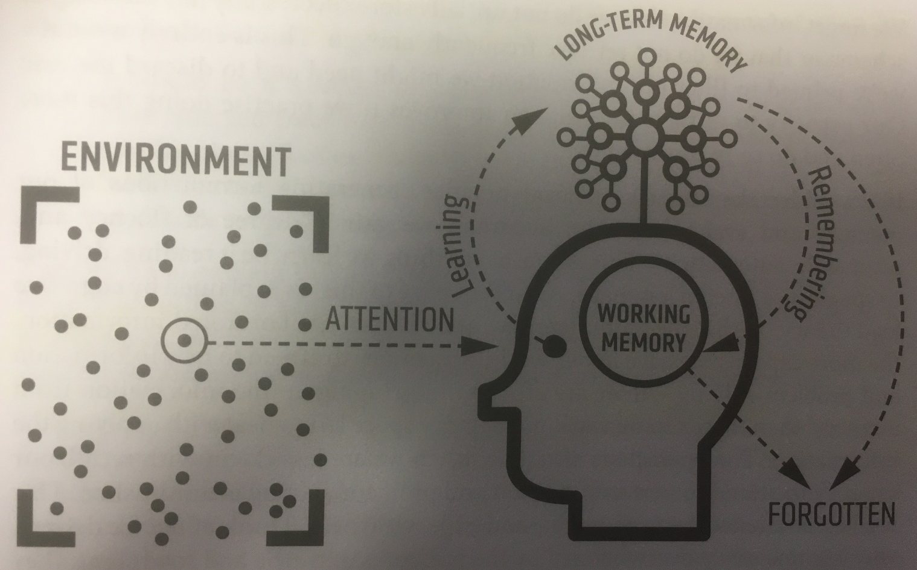

See section 4 of our Teaching and Learning Policy for more information as to how we teach to support this model. Our Teaching and Learning Policy can be found here.

The Teaching of DT

In EYFS, DT is taught as a fundamental part of topic work covered during the year. DT is about the children having the opportunities to explore and learn about the world they live in. The children’s work is related to the Communication and language, Physical Development, Understanding the World objectives set out in the Early Years Foundation Stage Curriculum.

Key Stages 1 and 2
At Key Stage 1, DT is about developing the process of Evaluation, Design, Create and Evaluate relating to the children’s own environment and the wonderful world around them. The children carry out enquiry inside and outside the classroom, developing their enquiry skills within the school grounds and immediate locality. In doing this, they ask specific questions about structures, mechanisms, cooking and nutrition, textiles, ICT, electrical systems, and use specific skills and resources, such as market research, improvements, classifying, identifying, drawing, sketching, labelling and questioning. At Key Stage 2, DT is about developing knowledge, skills and understanding relating to the process Evaluation, Design, Create and Evaluate and Love Faith. Love People. Love Learning. Page 6 of 8 the wider world and an appreciation of how DT is a shape their world. In doing this they ask specific questions and use skills and resources such as wheels, frames, CAMS, motors, circuits, textiles, food, electronic and digital technologies. At St. Francis, we use a variety of teaching and learning styles in our DT lessons. We use whole-class teaching methods and we combine these with enquiry-based research activities. We encourage children to ask as well as answer subject specific questions. We offer them the opportunity to use a variety of presentational devices.

- PLANNING
Planning of the subject has been completed to ensure progression in knowledge as the children move through the school. The Long-term plan for this subject area can be found on our curriculum section of our website: Curriculum Section of Website

The detail of content, including precise knowledge has been set for each year group as outlined in the Long-Term Plan. It is the role of the class teacher to place this into short-term planning to cover in their classes.
The teaching and learning policy demands that teachers plan the outlined content taking consideration of the following:
- Cognitive load
- Learning organisation
- Learning progression
- Learning steps
- Sequential – retrieval practice
- Mode A:Mode B Teaching
The Teaching and Learning Policy, section 5.8 (page 11), defines Mode A:Mode B teaching as:

During the planning process, the teacher will identify which type of teaching is required.

Mode A:
Every teacher needs to be able to deliver high-quality instructional teaching. This is Mode A.
Explaining, Modelling, Questioning, Checking for Understanding, Guiding Practice.
This is identifying when content requires explicit instruction.

Mode B:
Mode B teaching usually involves content that would benefit from a child-led, curious and inquisitive approach, for example, a science experiment. “I have put some resources on your table, explore and come up with some statements and/or questions to share”

Teachers will use instructional routines throughout Mode B teaching.

Unlike Mode A teaching, which will be a daily default, Mode B elements can be woven into the curriculum at varying frequencies. Some elements might be daily, some weekly or monthly, some might happen once per unit of learning or just once a year. Mode B elements offer a depth and richness that supplements the staple diet of Mode A. There are no hard and fast rules and whole lessons could easily be devoted entirely to one mode or the other.

Section five of the teaching and learning policy sets out the processes of planning in our school.

Our Teaching and Learning Policy can be found here.

- ASSESSMENT
Staff will carry out baseline assessments of children’s knowledge at the beginning of each DT unit in order to find their individual starting points. At the end of the lesson or series of lessons, pupils are given opportunities to demonstrate progress from this starting point. Pupils are encouraged to reflect upon their own learning. Staff will complete termly assessments linked to the areas of the DT curriculum each unit has covered.

Section six of the teaching and learning policy sets out the processes of assessment in our school.

Our Teaching and Learning Policy can be found here.

- SPIRITUAL, MORAL, SOCIAL AND CULTURAL (SMSC) DEVELOPMENT
Definition of SMSC:
Spiritual
Explore beliefs and experience; respect faiths, feelings and values; enjoy learning about oneself, others and the surrounding world; use imagination and creativity; reflect.

Moral
Recognise right and wrong; respect the law; understand consequences; investigate moral and ethical issues; offer reasoned views.

Social
Use a range of social skills; participate in the local community; appreciate diverse viewpoints; participate, volunteer and cooperate; resolve conflict; engage with the 'British values' of democracy, the rule of law, liberty, respect and tolerance.

Cultural
Appreciate cultural influences; appreciate the role of Britain's parliamentary system; participate in culture opportunities; understand, accept, respect and celebrate diversity.

Opportunities for SMSC throughout the curriculum offer is extremely important. Please see curriculum map to view the intentional and purposeful planning of SMSC learning.

- MONITORING
Termly monitoring will be carried out by the DT lead, through discussion with class teachers, viewing recorded work and speaking to pupils about their learning.

- SPECIAL EDUCATION NEEDS AND/OR DISABILITY
See our Special Educational Needs and/or Disability policy here.

- HEALTH AND SAFETY CONSIDERATIONS
- Painting – contact with skin, spillages and slip hazards
- Sewing – needle injury, cotton cuts
- Preparing and cooking food – cuts, stabbing injuries, lacerations, allergies, hygiene, spillages and slip hazards.
- Glue – contact with skin, hair and/or eyes
- Scissors – cuts and ‘nips’
- Glue gun – burns due to hot components and glue
- Balloons – hygiene and asthma
- Making holes – stabbing injuries, cuts and abrasions
- Using tools – cuts, lacerations, impact injury or abrasions
- Hand saw – cuts, eye injury, dust in eyes
- Cleaning up – dust and sharp objects
See our Health and Safety policy here.

- RESOURCES, INCLUDING SUITABLE TEXTS
See curriculum map with the above included. (Curriculum Section of Website)

- COMMUNITY LINKS – LOCAL AND GLOBAL
See curriculum map with the above included. (Curriculum Section of Website)

- VISITS, VISITORS AND EXPERIENCES
See curriculum map with the above included. (Curriculum Section of Website)

