St Francis Church of England Primary School
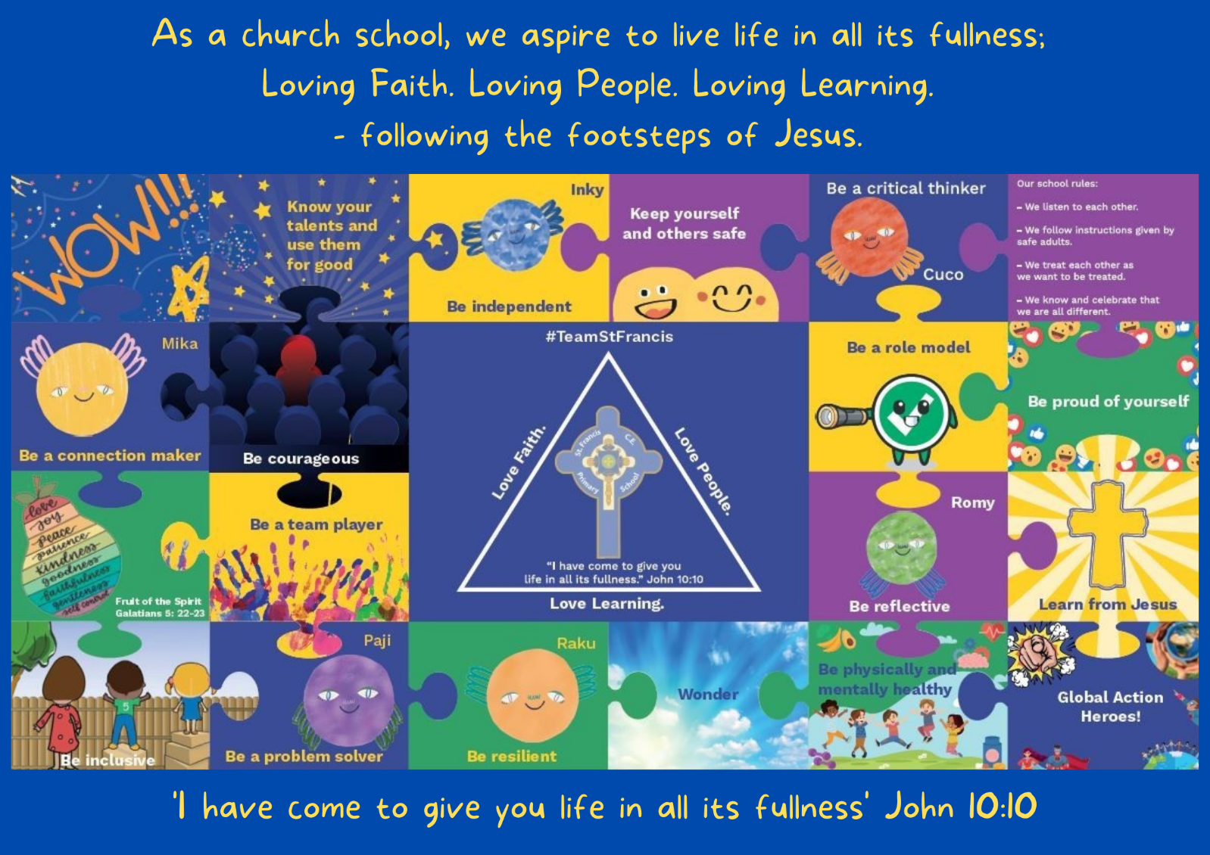

Our vision is at the core of everything we do. It underpins our teaching and learning, interactions and environment.

Policy Title:
Science

Date of Policy: | Summer Term 2020 |  | Review Cycle: | Annually
Policy Review Date: | Summer Term 2021 | Updates: | Updated teaching and learning policy
Policy Review Date: | Autumn 2022 | Updates: | School Vision jigsaw, the Teaching of Science.
Policy Review Date: |  | Updates:
Policy Review Date: |  | Updates:

Headteacher: J.Kewley Chair of Governors: N.Duffy

- MODEL OF CURRICULUM

- SUBJECT VISION
Our children are naturally curious to find out about their wonderful world. They engage in practical enquiry-based learning and use scientific vocabulary and knowledge with confidence so that they can explain what is occurring, make predictions and analyse causes. Our children investigate, explore and demonstrate a sense of excitement and inquisitiveness of natural phenomena and recognise how science (chemistry, biology and physics) will continue to shape their world

2.1 Science Principles
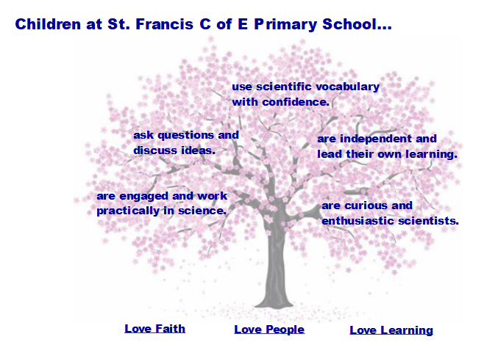

- LEGAL FRAMEWORK

This policy will have regard to the following statutory and non-statutory guidance within the primary national curriculum. Available at: Primary National Curriculum

- ROLES AND RESPONSIBILITIES
4.1 Role of Subject Leader

The Teaching and Learning Policy, page 3 – section 1.3 states:
‘Subject Leaders will:
- Develop and review curriculum policies and schemes of work in collaboration with colleagues.
- Ensure that all relevant required subject leadership paperwork is carried out, for example, subject action plan and leader reports.
- Take accountability for the progress of children in their given subject.
- Report on the effectiveness of the curriculum to the senior leadership team and the governing body.
- Provide professional advice to the governors’ curriculum sub-committee.
- Ensure their Scheme of Work details the following: National Curriculum coverage, Objectives, Precise Knowledge, Vocabulary, Links to visits/visitors/experience, Map of prior learning, Links to SMSC, Christian values and mission statement.
- Keep up-to-date through reading and attending relevant courses
- Sharing subject knowledge and pedagogy amongst colleagues to distribute best practice across the school’

4.2 Role of Class Teacher

The Teaching and Learning Policy, page 3-4 – section 1.4 states:
‘Teachers will:
- Teach using the instructional and pupil culture routine to echo the learning science the teaching and learning is based upon.
- Have strong formative assessment within lessons that drives their instruction to ensure children’s learning needs are met.
- Hold the mindset of ‘No-opt Out’; ensure 100% compliance and utilise routines to ensure high engagement in learning from all children, irrespective of ability
- Utilise mixed ability or flexible groups to meet need.
- Be reflective practitioners.
- Take on board all training opportunities provided by changing and adapting teaching pedagogy.
- Accurately monitor and evaluate their teaching against the national teaching standards and their appraisal targets.
- Seek professional dialogue and constructive criticism from senior leaders, teaching colleagues or subject leaders.
- Review and evaluate their planning regularly to ensure it meets with subject consistencies laid out in subject policy and the staff handbook.
- Set appropriate and challenging targets for pupils based on ability.
- Collaborate with colleagues to moderate pupil achievement.
- Involve parents and other professionals in the learning process.
- Complete all relevant assessment data required through the assessment cycle.
- Promote a growth mindset for the children, utilising metacognitive research.
- Consider the welfare and safety of children and act within the safeguarding policy as we believe effective learners have to be safe learners.
- Provide a challenging and stimulating curriculum, designed to encourage all children to reach the highest standards of achievement
- Ensure that their lessons develop children’s deeper thinking and use strategies to support the transference of knowledge to the long-term memory
- Be excellent role models, punctual, well prepared and organised.
- Have a positive attitude to change and the development of their own expertise.
- Ensure that their teaching promotes the love of learning through the use of a range of strategies, including visits, visitors and experiences.
- Manage behaviour consistently through the school’s behaviour policy

- EYFS PROVISION
The teaching of this subject relates to the following areas of the EYFS framework:

ELG 15. The Natural World: Explore the natural world around them, making observations and drawing pictures of animals and plants. Know some similarities and differences between the natural world around them and contrasting environments, drawing on their experiences and what has been read in class. Understand some important processes and changes in the natural world around them, including the seasons and changing states of matter.

The EYFS statutory framework can be found at: EYFS Statutory Framework
The EYFS non-statutory Development Matters guidance can be found at: Development Matters

- THE NATIONAL CURRICULUM
The teaching of the curriculum for the named subject links directly and ensures appropriate coverage of the Primary National Curriculum.

The Primary National Curriculum can be found at: Primary National Curriculum

- OUR TEACHING MODEL
Our teaching and learning is based upon research around how learning works. This is the foundation as to how we teach at St. Francis CEP School.

Tom Sherrington – Rosenshine’s Principles in Action
A simple model for how memory works is based on the concept of building schemata in our long-term memory, as follows:
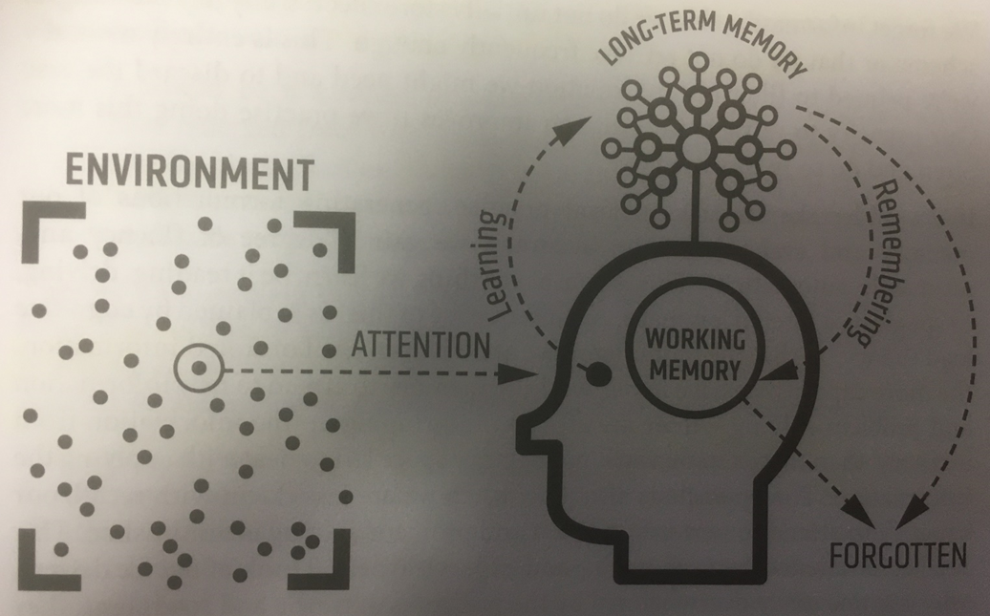

See section 4 of our Teaching and Learning Policy for more information as to how we teach to support this model. Our Teaching and Learning Policy can be found here.

The Teaching of Science

- The National Curriculum document for Primary Science 2014 sets out a clear, full and statutory requirement for all children. It determines the content of what will be taught, and sets attainment targets for learning.
- The science programmes of study set out what should be taught at Key Stage 1 and 2 and The Foundation Stage programmes of study for Understanding of the World are set out in the EYFS.
- ‘Working scientifically’ is described separately in the programme of study, but must always be taught through and clearly related to the teaching of substantive science content in the programme of study. Throughout the notes and guidance, examples show how scientific methods and skills might be linked to specific elements of the content. • Pupils should read and spell scientific vocabulary at a level consistent with their increasing word reading and spelling knowledge.
- A knowledge organiser should be available for each unit.
- Follow guidance given from our unit of learning: Displays will need to have:
  - Science vocabulary appropriate to the year group found on the National Curriculum Vocabulary document (written by children KS2 onwards) including a Widget found on https://widgitonline.com/login
  - What the children already know to be displayed in a thought bubble (post it notes added and misconceptions addressed)
  - What the children want to know displayed on each class display in speech bubbles (written by children KS2 onwards in speech bubbles)
  - Answers found out by the children added to the speech bubbles (written by children KS2 onwards in speech bubbles)
  - Prior learning to be displayed as a picture of the previous working wall, QR codes can also be added.
  - Working Scientifically skill to be displayed.
  - Strand (chemistry, physics, biology) to be displayed.
- CLEAPSS to be accessed when conducting experiments and using equipment for Health and Safety. https://primary.cleapss.org.uk/h

- PLANNING
Planning of the subject has been completed to ensure progression in knowledge as the children move through the school. The Long-term plan for this subject area can be found on our curriculum section of our website: Curriculum Section of Website

The detail of content, including precise knowledge has been set for each year group as outlined in the Long-Term Plan. It is the role of the class teacher to place this into short-term planning to cover in their classes.
The teaching and learning policy demands that teachers plan the outlined content taking consideration of the following:
- Cognitive load
- Learning organisation
- Learning progression
- Learning steps
- Sequential – retrieval practice
- Mode A:Mode B Teaching
The Teaching and Learning Policy, section 5.8 (page 11), defines Mode A:Mode B teaching as:

During the planning process, the teacher will identify which type of teaching is required.

Mode A:
Every teacher needs to be able to deliver high-quality instructional teaching. This is Mode A.
Explaining, Modelling, Questioning, Checking for Understanding, Guiding Practice.
This is identifying when content requires explicit instruction.

Mode B:
Mode B teaching usually involves content that would benefit from a child-led, curious and inquisitive approach, for example, a science experiment. “I have put some resources on your table, explore and come up with some statements and/or questions to share”

Teachers will use instructional routines throughout Mode B teaching.

Unlike Mode A teaching, which will be a daily default, Mode B elements can be woven into the curriculum at varying frequencies. Some elements might be daily, some weekly or monthly, some might happen once per unit of learning or just once a year. Mode B elements offer a depth and richness that supplements the staple diet of Mode A. There are no hard and fast rules and whole lessons could easily be devoted entirely to one mode or the other.

Section five of the teaching and learning policy sets out the processes of planning in our school.

Our Teaching and Learning Policy can be found here.

- ASSESSMENT
Assessment in Science is mainly formative. Teachers will assess within lessons and outside of lesson to provide feedback in order for children to improve their work through the unit. At the end of a unit, teachers will monitor the impact of the content taught within the unit. At the end of a term, based on the work produced at the end of each unit, teachers will assess whether children are at Below, Expected or at Greater Depth Secure. Teachers will assess learning in each lesson through a series of recall and retrieval activities

Section six of the teaching and learning policy sets out the processes of assessment in our school.

Our Teaching and Learning Policy can be found here.

- SPIRITUAL, MORAL, SOCIAL AND CULTURAL (SMSC) DEVELOPMENT
Definition of SMSC:
Spiritual
Explore beliefs and experience; respect faiths, feelings and values; enjoy learning about oneself, others and the surrounding world; use imagination and creativity; reflect.

Moral
Recognise right and wrong; respect the law; understand consequences; investigate moral and ethical issues; offer reasoned views.

Social
Use a range of social skills; participate in the local community; appreciate diverse viewpoints; participate, volunteer and cooperate; resolve conflict; engage with the 'British values' of democracy, the rule of law, liberty, respect and tolerance.

Cultural
Appreciate cultural influences; appreciate the role of Britain's parliamentary system; participate in culture opportunities; understand, accept, respect and celebrate diversity.

Opportunities for SMSC throughout the curriculum offer is extremely important. Please see curriculum map to view the intentional and purposeful planning of SMSC learning.

- MONITORING
Monitoring will be undertaken on a half termly basis by the subject lead and could include, book looks, lesson visits, child voice/pupil conferencing and classroom visits to monitor displays. See monitoring schedule.

- SPECIAL EDUCATION NEEDS AND/OR DISABILITY
See our Special Educational Needs and/or Disability policy here.

- HEALTH AND SAFETY CONSIDERATIONS

Primary Science Health and Safety Policy

This document is intended for use as guidance only. The purpose is to provide example elements, structures and information commonly found in such policies. Schools and academies must ensure that any policies derived from the guidance in this model policy reflect their own specific requirements, such as setting, pupil ages, and percentages of pupils with special educational needs.

Contents:
Statement of intent
- Legal framework
- Safety file
- Risk assessments
- Emergency procedures
- Training
- Purchasing equipment
- Safety checks
- Living organisms
- Monitoring and review
Appendices
  - Emergency treatment procedures

Statement of intent
St. Francis CE Primary School believes that teaching science in primary schools should be exciting, practical and rewarding for pupils. With this in mind, teachers will plan lessons that engage with pupils and follow the national curriculum.

Practical science lessons are potentially hazardous; therefore, teachers will take the safety of these lessons very seriously. By following the rules and procedures outlined in this policy, all members of staff will be free to plan interesting lessons, whilst ensuring that pupils and staff remain safe.

Signed by:
 | Headteacher | Date:
 | Chair of governors | Date:
- Legal framework
  - This policy has due regard to relevant legislation, including, but not limited to the following:
- The Health and Safety at Work etc. Act 1974
- The Reporting of Injuries, Diseases and Dangerous Occurrences Regulations (RIDDOR) 2013
- The Workplace (Health, Safety and Welfare) Regulations 1992
  - This policy will be implemented in conjunction with the school’s:
- Health and Safety Policy.
- Near-Miss Policy.
- Risk Assessment Policy.
- Manual Handling Policy.
- Safety file
  - The headteacher is responsible for creating and monitoring a school safety file. This file will contain:
- The accident and near miss record, along with the corresponding report forms.
- The Health and Safety Policy.
- Emergency contact details.
- The Emergency Incident Policy.
- An inventory of all science equipment.
- Copies of letters and circulars sent to the school by the LA and CLEAPSS.
- Risk assessments
  - Risk assessments will be completed before any practical science lesson. Existing risk assessments, which cover lessons, may be used again if they are up-to-date.
  - If a risk assessment does not exist, one will be created to cover the specific lesson being planned.
  - It is the responsibility of the headteacher to ensure that all risk assessments are reviewed annually. Risk assessments for hazardous materials will be reviewed termly.
- Emergency procedures
  - If an accident occurs, the teacher in charge will decide on the correct course of action.
  - If the teacher in charge is not a qualified first aider, one will be contacted at the earliest opportunity.
  - If the first aider believes that further treatment is needed, or if there is any doubt, arrangements will be made for transporting the injured party to a secondary location, such as a local NHS drop in centre, to receive treatment.
  - If the first aider believes that emergency treatment is required, an ambulance will be called.
  - Emergency procedures will always be followed when the incident involves the ingestion, inhalation or absorption of hazardous materials.
  - Following the incident, the teacher concerned will complete and submit an accident report form.
  - If an accident occurs away from the school, a report will be submitted to the headteacher.
  - The headteacher will be responsible for investigating the incident.
  - Any accident will be reported to the local council’s health and safety team.
  - If an accident occurs away from the school, it will be reported to the HSE using the RIDDOR notification process.
  - Following the investigation, a report will be presented to the governing body.
- Training
  - It is the responsibility of the headteacher to ensure that all members of staff have received adequate training for managing the risks associated with primary science lessons.
  - It is the responsibility of the headteacher to ensure that all new members of staff receive adequate training as part of their induction programme.
  - Regular refresher safety training will be arranged on a termly basis, to ensure that all members of staff are up-to-date.
- Purchasing equipment
  - All purchased equipment will be safe and appropriate for primary pupils.
  - Equipment will only be purchased from recognised educational suppliers.
  - If equipment is donated, it will undergo safety checks by a qualified technician.
  - Equipment will only be used once it has been approved and recorded by the headteacher.
- Safety checks
  - All equipment will undergo safety checks every six months.
  - A record of all safety checks will be kept in the safety file.
  - All equipment will be safely stored in the science cupboard.
  - A qualified technician will check the school electrical systems annually.
  - If equipment is found to be defective, it will be disposed of safely.
  - If a member of staff has concerns about a piece of equipment, the headteacher will be notified. A qualified technician will check the equipment, making the decision as to whether to continue using the equipment.
- Living organisms
  - Any plants, animals or micro-organisms purchased by the school will be acquired from reputable sources.
  - Risk assessments will be completed before any living organism enters the premises.
  - CLEAPSS guidance will be followed on any human cell activities, such as, looking at cheek cells or investigating blood.
  - Biological cultures will remain closed, with lids taped down. They will be disposed of by autoclaving.
- Monitoring and review
  - This policy will be reviewed and amended if a serious incident occurs. Any changes will be communicated to all members of staff.
  - The headteacher is responsible for reviewing this policy at least annually.

Emergency treatment procedures
When an accident occurs, it is important to act immediately. By following the steps outlined below, the member of staff who is present can provide effective assistance to the victim of an accident. These details will be posted in prominent positions in all classrooms. All members of staff will familiarise themselves with these procedures.
Chemicals splashed in the eye
The eye(s) will immediately be washed in running water for a minimum of 10 minutes. The flow of water will be slow and the eyelids will be held back. The victim will always be taken to hospital.
Chemicals splashed on the skin
The affected area will be washed in running water for five minutes until all traces of the chemical have been washed off. If the chemical is still present after this time, soap and water will be used until it disappears.
Chemicals in the mouth
The victim’s mouth will be immediately washed out. In all circumstances the victim will be taken to hospital. Details of the chemical should be given to the hospital staff.
Burns and scalds
The affected area will be immersed in cold water or placed under running water. A qualified first aider will decide whether further treatment is required.
Cuts to the skin
Pressure will be applied on, or close to, the cut. The victim will be sat down; if possible, the wound will be raised higher.
Toxic gas
The victim(s) will vacate the area and remain in the fresh air until a qualified first aider arrives.
Hair on fire
The victim’s head will be smothered with a cloth. A qualified first aider will decide whether further treatment is required.
Clothing on fire
A fire blanket will be used to smother the affected area. If one is not available, a thick cloth or garment will be used. If the victim’s skin is burned they will be taken to the hospital.
Electric shock
Contact will be broken immediately; this will be done by taking the plug out of the mains point. If the victim needs to be moved, this needs to be done by using a non-metallic object.

- RESOURCES, INCLUDING SUITABLE TEXTS
See curriculum map with the above included. (Curriculum Section of Website)

- COMMUNITY LINKS – LOCAL AND GLOBAL
See curriculum map with the above included. (Curriculum Section of Website)

- VISITS, VISITORS AND EXPERIENCES
See curriculum map with the above included. (Curriculum Section of Website)

